IRVING FIRE DEPARTMENT
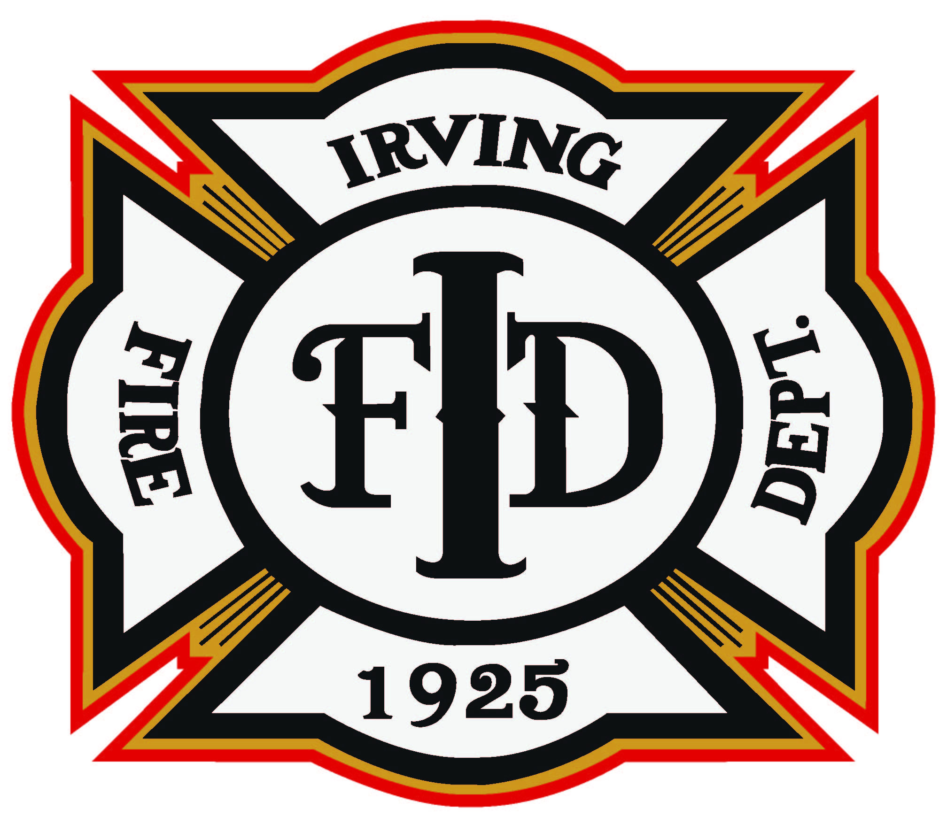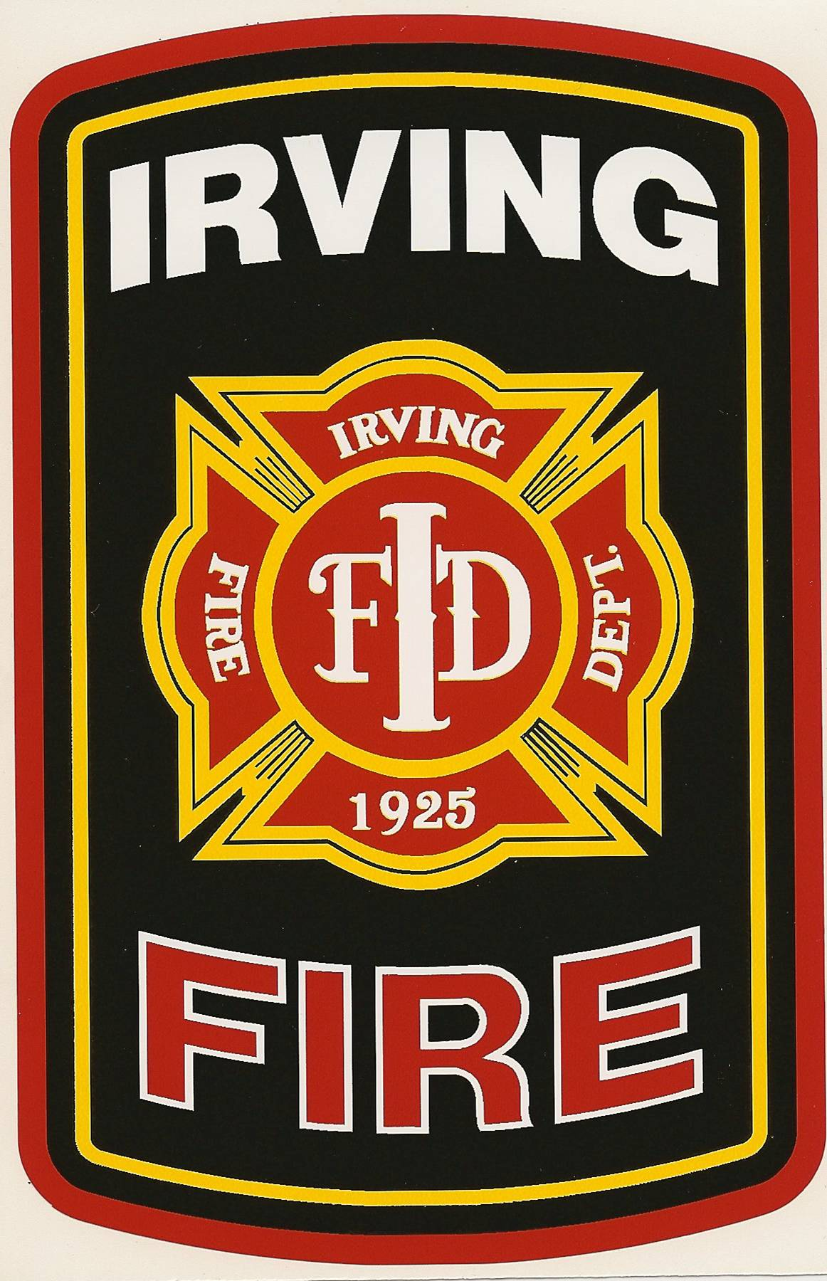
Emergency Operating Guidelines

Origin Date: 12/23/03 Revision Date: 6/24/24 Chief Approval:
Approved by Council: 8/3/23
20.4 – Traffic Incident Management
It is the policy of the Irving Fire Department (IFD) to position apparatus and other emergency vehicles on streets, roads, highways, or expressways to protect the incident scene, including Fire Department personnel, law enforcement officers, tow service operators, and the public.
It is our goal to mitigate the incident as quickly as possible and establish a safer work environment for on-scene personnel. Traffic disruption will be necessary but expected. This job function is arguably the most dangerous part of our jobs and must always be treated with that in mind. Members shall always operate in a manner that provides a protected environment or “envelope” at all roadway incidents.
The strategies to increase the safety and situational awareness of personnel on the scene of thoroughfare incidents are unique for each incident. Battalion Chiefs (BCs), Officers-in-Charge (OICs) EMS Officers (SDOs), and designated Incident Safety Officers (ISOs) will assess the situation at hand to determine the best course of action. They must establish theirs and their personnel’s positions as best suited for Command and observation.
Should additional resources be needed to fulfill the establishment of a Safety Zone, then those resources should be requested as early as possible to prevent delay.
Note: Blockers are not intended to close or divert traffic for situations such as high water, construction, or disabled vehicles. Officers shall use discretion on whether or not a request for a Blocker is appropriate and have the authority to cancel a request for a Blocker for a purpose other than it was intended.
A list of definitions is contained within Appendix A.
- Battalion Chief Responsibilities
  - On all major accidents where an IFD Blocker is sent, a Battalion Chief shall be dispatched for overall scene safety and incident management.
    - Shall announce and assume Command.
    - Coordinate with Alarm Office for necessary resources.
    - Coordinate with Irving Police Department (IPD) and Alarm Office for closure of thoroughfare(s).

    - Control overall scene safety by establishing a Safety Zone. The Safety Zone is an area protected by apparatus and will be the location in which personnel can perform their duties. The Safety Zone may be moved or adjusted as necessary in order to keep all personnel within that area at all times, unless otherwise approved by the Incident Commander (IC).
    - Establish a line of communications with the on-scene IPD officer in charge. The Public Safety channel may be utilized with coordination from the Alarm Office.
    - Coordinate through the Alarm Office or the IPD officer in charge to assist in blocking downstream thoroughfare access ramps when the roadway is shut down upstream.
    - Appoint an Incident Safety Officer (ISO) as needed.
    - Request tow trucks through the Alarm Office as needed. Coordinate with IPD if possible, but at a minimum, alert the Alarm Office to notify IPD of the request. Be sure to specify the need for a standard, flat-bed, or heavy-duty type.
    - The Incident Commander (IC) must recognize the unique nature of every scene and ask for assistance as quickly as possible. Creative and critical thinking skills must always be employed to keep personnel safe.
    - The on-scene IC may disregard the Battalion Chief at their discretion.
Note: In the event both Battalion Chiefs are assigned to other incidents, the EMS Officers (SDOs) shall serve as backup Incident Commanders (IC). The order of assignment shall be 522 first and 521 second.
- Company Officer Responsibilities
  - Establish command if not already done so.
  - Establish a Safety Zone utilizing the Blocker, fire apparatus, and any available environmental barriers such as Jersey barriers, concrete walls, etc.
  - Establish and communicate a Safety Zone to on-scene personnel. The Safety Zone shall encompass where personnel can assess, package, and treat patients and to mitigate the incident.
  - Personnel shall not work outside of the Safety Zone for any reason without IC approval. If necessary, the Safety Zone may be moved or adjusted to accommodate changes in conditions.
  - Truck Officers are responsible for the Blocker operator and their truck personnel remaining on the apparatus to work as upstream and downstream spotters unless extrication or manpower is requested. At all times, one member MUST remain in the cab of the Truck to serve as an upstream spotter.
  - If extrication is necessary, the IC shall request the nearest fire apparatus, SDO or a BC to respond to act as the upstream spotter. At all times, one member MUST remain in the cab of the Truck to serve as an upstream spotter.
- EMS Officer (SDOs) Responsibilities
  - Anytime a major thoroughfare is closed, or if the IC requests, one (1) EMS Officer shall be dispatched. Their primary role shall be to act as a downstream spotter and warn personnel of incoming vehicles that may pose a threat to on-scene operations.
  - EMS Officers (SDOs) should work with a liaison from Law Enforcement to coordinate for additional resources to cover downstream entrance/exit ramps which could serve as a means of access for a wrong-way driver. The Public Safety channel may be utilized with coordination from the Alarm Office.
- Personnel Safety Guidelines - Specific procedures to be used by all IFD members at thoroughfare incident scenes including:
  - Be alert and aware of approaching traffic.
  - Whenever possible, avoid turning your back to approaching traffic. For example, while sweeping debris, sweep while facing each other to look over each other’s backs for approaching traffic from each direction.
  - Face oncoming traffic if placing and retrieving cones and/or flares.
  - Establish an initial “block” with the first arriving emergency vehicles.
  - Always wear a high visibility reflective vest. Must be worn on the outside when using full protective clothing. The high visibility vest shall meet ANSI-ISEA 107 and be NFPA 701 compliant.
  - Wear a departmental issued helmet. No exceptions. The only authorized helmets currently are EXFIL®SAR (Team Wendy) helmets, and structural firefighting type. Members shall wear their structural firefighting helmet while fighting fire and while wearing SCBA; otherwise, the Team Wendy helmets shall always be worn while on scene. 521 and 522 will keep a supply of Blue Team Wendy helmets to be used for interns. The EMS Supervisor will issue the Team Wendy helmet on the interns first shift and will retrieve the helmet the first shift after the intern has completed their rotation. Station personnel will ensure the intern is familiar with operation of the adjustable headgear and proper use.
  - Turn off all emergency vehicle headlights and spotlights that are not contributing to lighting the emergency scene and turn on all clearance and marker lights and emergency warning lights.
  - Use Fire Department apparatus and police vehicles to initially redirect the flow of moving traffic.
  - Establish advance warning and adequate transition area traffic control measures upstream of the incident to reduce travel speeds of approaching motorists.
  - IPD Vehicles should be offered position within the Shadow to deter motorists from “dipping” back into the work zone after passing the Blocker while providing a safe working environment for IPD officers. An additional consideration would be for IFD Blocking apparatus to set cones in the Shadow for added safety.

  - Company Officers shall use discretion when cones are requested to be set in the Transition Area. IC approval must be obtained prior to leaving the confines of the Safety Zone for this task. The Company Officer may choose not to set out cones if conditions are too hazardous. Firefighter safety shall be the deciding factor. The Company Officer shall relay his decision if they choose not to use cones due to hazardous conditions to the IC and other members working downstream. Private vendor or TXDOT equipment will be requested to place cones upstream in the Transition area upon their arrival.
  - It is the responsibility of all officers on scene to ensure that all IFD Members wear the required protective clothing and follow personnel protective guidelines.
- Standard highway or thoroughfare incident apparatus response shall include:
  - MICU
  - Engine Company
  - Truck Company
  - Blocker
  - Battalion Chief
- Procedures for placement of emergency vehicles when operating in or near moving traffic.
  - Position first-arriving apparatus to protect the scene, patients, and emergency personnel. Initial apparatus placement should create a “block” establishing a physical barrier between the incident scene and approaching traffic.
  - Use apparatus placement to slow approaching motorists and redirect them around the scene.
  - Use Fire Department apparatus to block at least one (1) additional traffic lane more than already obstructed by the involved vehicle(s).
  - Position apparatus to protect the Driver from being exposed to approaching traffic while operating at or near the pump panel.
  - Park large apparatus to create a Safety Zone for MICUs and other Fire Department vehicles. Operating personnel, equipment, and patients shall remain in the Safety Zone created by the blocking apparatus. To increase safety, IPD vehicles should also be positioned inside the Safety Zone, if possible.
  - Establish a Safety Zone sufficient to include all patient vehicles, roadway debris, the patient triage and treatment area, the extrication work area, personnel, tool staging area, and the patient loading zone. Personnel shall not move outside of the Safety Zone for any reason without approval of the IC. If necessary, the size or configuration of the Safety Zone must be adjusted to accommodate work within. If circumstances dictate, a second Safety Zone may need to be created with additional apparatus or move the existing one.
  - Position the MICU within the confines of the Safety Zone of the accident and beyond the accident itself at the furthest point downstream. The MICU will position itself with the rear door patient loading area away from the nearest lanes of moving traffic. This positioning will provide safety and a quicker means of egress after loading the patient(s).
  - Stage unneeded emergency vehicles off the roadway or return them to service whenever possible.
  - At intersections, or where the incident is near the middle lane of the roadway, protect all sides of the incident.
  - Thoroughfare Operations – High-volume limited access thoroughfares include highways, expressways, toll ways, and multi-lane roadways. The Police Department and Department of Transportation (DOT) have a desire to keep the traffic moving on these high-volume thoroughfares. For the safety of operating personnel and the patients involved, any or all lanes, shoulders, and entry/exit ramps of these limited access highways may be completely shut down, if necessary. However, the closing of freeways should rarely occur, and only for as long as necessary. Freeway lanes should be cleared and re-opened as soon as possible, after patients have been extricated from vehicles, to minimize interruptions in traffic and reduce the incidence of secondary accidents. Safe parking procedures at expressway and limited-access, multi-lane roadway incidents include:
  - The first-arriving engine company should establish a block of the lane(s) occupied by the vehicle(s) plus one additional lane, if possible.
  - A truck company and blocker are dispatched to all incidents on limited-access, high-volume expressways, and highways within the city to:
    - Establish an upstream block occupying a minimum of two (2) lanes plus the paved shoulder of the highway, or three (3) driving lanes of traffic upstream of the initial block provided by the first-arriving apparatus.
      - Position apparatus considering all factors that limit sight distances of the approaching traffic, including ambient lighting conditions, weather-related conditions, road conditions, curves, bridges, hills, and overpasses or underpasses.
      - Apparatus shall be positioned far enough upstream of the initial block to provide a safe distance in case the apparatus is struck, but not so far upstream as to allow vehicles to pass the apparatus, re-enter the blocked lanes, and endanger either the company providing the initial block or the companies inside the Safety Zone. If, due to road conditions the Shadow is lengthy, IPD officers may be requested to position their vehicles at strategic locations within the Shadow to deter passing motorists from “dipping” into the Shadow after passing the Blocker.
      - Tiller operators at the back of the apparatus need to be especially aware of the traffic situation. Once the apparatus has been positioned for proper blocking, the rear tiller operator shall exit their cab on the non-traffic side and proceed to join their crew inside the main cab of the apparatus.
      - Truck crews shall not leave the confines of the apparatus to assist on the accident scene unless extrication or manpower is requested. The primary purpose of the truck crew is to be alert to upstream, and if possible, downstream traffic issues.
      - Notify the IC of any approaching traffic not responding to the transition, tapering, and merging cautions. A series of long horn blasts should be used to audibly warn all operating personnel of a concern for the actions of an approaching motorist.
      - In situations where the truck company is without a Blocker, the truck company shall maintain their blocking assignment until a Blocker assumes blocking position or when dismissed or cleared by the IC or the fire company providing the initial block.
  - IFD and IPD crews should work together to clear the roadway of involved vehicles as soon as safely possible to provide the best assurance of crew safety. Remove crews, apparatus, and equipment from the highway promptly to reduce exposure to moving traffic and minimize traffic congestion. IFD command will consult with the IPD officer-in-charge prior to removing any vehicles or other personal property from the roadway.
- To clear the roadways as soon as possible, Officers are reminded a State of Texas statute applies to our diligence in accomplishing this action.
      - Texas Transportation Code § 550.022. Accident Involving Damage to Vehicle (b). If an accident occurs on a main lane, ramp, shoulder, median, or adjacent area of a freeway in a metropolitan area and each vehicle involved can be normally and safely driven, each operator shall move the operator's vehicle as soon as possible to a designated accident investigation site, if available, a location on the frontage road, the nearest suitable cross street, or other suitable location to complete the requirements of Section 550.023 and minimize interference with freeway traffic.
- Protection from liability when removing vehicles from roadways, to include disabled vehicles.
- Texas Transportation Code § 545.3051(a) (e) Notwithstanding any other provision of law, an authority, a fire department, or a law enforcement agency is not liable for any damage to personal property removed from a roadway or right-of-way under this section, unless the removal is carried out recklessly or in a grossly negligent manner.
  - Officers must be cognizant of the fact that moving a vehicle outside of law enforcement’s presence may create a problem with the evidence of a crime. In these circumstances when the evidentiary nexus is broken, an affidavit may be required from the personnel present during the removal or relocation of the vehicle(s). Best practice is not to move any vehicles when there is the possibility of a crime, i.e. D.U.I., car theft, road rage, etc. Coordination with IPD when a vehicle needs to be relocated is always warranted.
  - If the hazard needs to be removed prior to consultation with an on-site IPD officer, the consultation will take place between IFD dispatch and IPD dispatch. The documentation of the scene and the photo retention process shall be completed as follows:
    - ONLY a city issued cell phone shall be used to document the scene. IFD personnel shall NOT use personal cell phones.
    - Photographs are taken of each vehicle(s) showing their respective location to other vehicles involved, or any stationary object for a point of reference.
    - It may be necessary to take photographs of the vehicle(s) from multiple angles to provide a clear assessment of where the vehicles were located and the damages that occurred prior to relocation.
    - If an IPD officer arrives on-scene prior to IFD personnel clearing the scene, the IFD officer that took the photos will provide the IPD officer-in-charge with their city email address. Otherwise, after returning to the fire station, the IFD officer will contact the Alarm Office to assist in identifying the IPD officer-in-charge through IPD dispatch.
      - The IPD officer will email the IFD officer a link to the website evidence.com;
      - The IFD officer will download the photos to the website; and
      - Once the photos have been downloaded to the website address, the photos are deleted from the city phone.
  - If the hazards have been mitigated and IPD does not want to move vehicles, Officers are authorized to offer the use of the Blocker, clear the scene, and return to retrieve the Blocker when IPD has completed their tasks.
- Disabled vehicles may be moved utilizing a Blocker when conditions become too dangerous for incident management on the roadway.
- Photo documentation shall apply as listed above prior to relocation.
- The roadway should be completely shut down while relocating the vehicle(s).
- Officers should consider the placement of a hose line when the vehicle(s) have been damaged to the point unidentifiable fluids have leaked from the vehicle and there is a possibility of creating sparks and or friction when the vehicle is being relocated.
- Utilize “J” Hooks and chains that are a minimum of Grade 70.
- The only authorized points of attachment on the Blocker are the front tow hooks and the rear tow hooks located under the tailboard.
- Points of attachment on the disabled vehicle shall be to a secure location that is affixed to a frame member. Never attach a “J” Hook or chain to sheet metal or body components.
- All members shall move away from the vehicle twice the length of the chain being used.

Exception: When a vehicle is disabled but is capable of rolling, a member may be used to steer or apply the brakes in order to prevent the vehicle from rolling into the Blocker or other object. EXTREME CAUTION is advised as to not “jerk” the vehicle in any manner in which the “J” Hooks or chains are stressed and or can become unattached and become a projectile.
- A spotter shall be used on the driver’s side of the Blocker in which the Blocker driver can hear audible commands. The spotter shall maintain the chain safety distance.
- The Blocker driver shall use steady pulling pressure preventing slack from developing in the chains and “J” Hooks. The Blocker driver shall never accelerate to the point the vehicle is “jerked”.
- Tow Operations - The current towing contract awardee is responsible for tow operations within Irving City Limits.
  - IFD Alarm Office will notify the towing company when IFD field Officers request the need. IPD Dispatch will be notified anytime the Alarm Office contacts the towing company to request a tow truck. (Reference Section A., 1., h.)
  - Company Officers are responsible for notifying the Alarm Office as soon as a Tow Truck arrives on scene. Alarm Office personnel are responsible for placing a note on the incident of that arrival when notified.
- Private Entity Blocking Apparatus (PEBA) Deployment - Several roadway construction companies operate a rolling safety barrier vehicle. These vehicles are equipped with appropriate crash barriers and directional signage.
  - On major thoroughfares under construction, the Alarm Office shall request the respective company deploy their PEBA to the scene.
  - IFD crews will notify the Alarm Office when a PEBA arrives on-scene. Alarm Office personnel are responsible for placing a note on the incident of that arrival when notified.
  - IFD crews will notify the Alarm Office if a PEBA is not needed.
  - If no PEBA has arrived on-scene within thirty (30) minutes, the IC will notify the Alarm Office. The Alarm Office may also prompt on-scene crews for this information.
- IFD uses retired fire apparatus to serve as blockers. This program is expected to extend the life of newer apparatus by decreasing opportunities to be damaged and placed out of service from impacts on the highway. These vehicles are referred to as an IFD Blocker along with the station of assignment.
Example: “IFD Blocker 3”, “IFD Blocker 7”, “IFD Blocker 8”, “IFD Blocker 12”, etc.
  - IFD Blockers are stored at designated fire stations throughout the city as available. IFD Blockers are paired with truck companies.
  - IFD Blockers carry an assortment of equipment and materials with a minimum of:
    - Oil sorb stored in yellow buckets
    - 3/8-inch 20-foot chain, Grade 80
    - V-Bridal chain with J hooks
    - Flares (2 boxes)
    - Traffic cones (10 cones)
    - Hazmat booms (2 boxes)
    - Street broom (2)
    - Scoop shovel (2)
    - Water cutoff key (1)
  - Blocker Station Captains shall ensure their oil sorb reserve inventory is maintained at five extra bags.
  - Anytime a Blocker is out of service for repair or maintenance, a reserve Engine is utilized to take its place as the Blocker.
  - A priority list of the reserve Engines is established by Fire Administration, and maintained in the Alarm Office in order to determine which reserve Engine is utilized to fill the Blocker vacancy.
  - The first priority remains for reserve Engines to move up and fill in or replace a front-line Engine as needed. As a second priority, reserve Engines will be used as a temporary replacement Blocker.
  - When a reserve Engine is utilized as a Blocker, the Blocker Station Officer is responsible to inspect, inventory, and maintain the apparatus in a ready state. This may entail removing equipment and supplies from their regular Blocker and transferring to the reserve Engine.
  - Station Officers are responsible for updating the IFD Reserve Equipment Status Report to reflect Blocker availability and will designate if a reserve Engine is being utilized as a Blocker.
  - Upon dispatch to a major accident with blocking, the truck company will respond with a firefighter following in an IFD Blocker. Once on scene, the IFD Blocker will be positioned upstream as the primary blocker protecting the truck company and any other equipment and crews working downstream in the Safety Zone.
  - When arrival on scene, the Blocker operator shall assure all emergency lighting is turned on, arrow boards are indicating the correct path of travel, and the digital sign board displays the appropriate message for the oncoming traffic.
  - The digital sign board is pre-programmed with numerous messages and directional arrow configurations. There are three (3) priority messages (Arrow Left, Slow Down, Arrow Right) on the home screen for expedition of use. The priority messages should not be changed; however, Blocker operators should select the most appropriate message to display for the current traffic directional need.
  - During nighttime operations or when visibility is diminished, the Blocker driver shall activate the LED flood lights illuminating the area around the Blocker.
  - Once positioned, the firefighter will exit the IFD Blocker and rejoin their crew.
  - Once no longer needed, the IFD Blocker will be cleared and returned to the station. If the company that originally set the IFD Blocker in position is no longer on scene, one of the remaining crews on scene will return the IFD Blocker to its assigned quarters.
  - Prior to September 15th of each year, Station Captains at Blocker Stations are responsible to check the integrity of the gel inside the water tank. If the gel is broken down or needs to be reconstituted, additional Sodium Polyacrylate may be obtained through the Property Room. The concentration in a tank is 50 pounds of powder to 500 gallons of water. Reconstitution should only take a few pounds. Any spillage of the gel may be broken down with ordinary table salt and water.
- Alarm Office Responsibilities
- The Irving Fire Department Alarm Office plays a vital role in the management of incidents on thoroughfares. Some guides and suggestions include:
- The Alarm Office shall have a dedicated dispatcher monitoring the incident when Command has been established. That incident is the only priority for that dispatcher.
- The Alarm Office has the responsibility of managing the use of Blockers. Alarm Office personnel shall deny usage outside of protecting Fire apparatus, Law Enforcement vehicles, and First Responders.
- Requests for Blocker usage other than protection for First Responders and their apparatus/vehicles requires approval from the Assistant Chief of Operations, or after hours, from the On-Call Chief.
- Tow operators are included in the definition of a First Responder while cleaning up an accident scene. However, tow operators should be cautioned against leaving the Safety Zone to pick up debris without the benefit of blocking apparatus.
- Alarm Office shall keep track of, and place notes on, incidents related to wrecker on-scene, TXDOT on-scene, utilities, PEBA, etc.
- Alarm Office shall prompt on-scene companies if no report of wrecker on-scene after thirty (30) minutes.
- Should IPD contact the Alarm Office asking for additional equipment, verify that the IFD OIC is aware of the need and agrees with the request prior to dispatch.

Appendix A
Definitions - The following terms are common to incident operations, post-incident analysis, and training activities related to working in or near moving traffic.
- Advance Warning – Notification procedures that alert approaching motorists to adapt their normal driving to accommodate the emergency traffic control measures ahead of them.
- Block – Positioning Fire Department apparatus, or other agency vehicle, at an angle (approximately 45°) to the lanes of traffic, creating a physical barrier between upstream traffic and the Safety Zone. The block shall be maintained until all vehicles are removed from the roadway and the scene is cleared by the Fire Department and/or Police Department.
- Buffer Zone – The distance or space between personnel and vehicles in the Safety Zone and nearby moving traffic.
- Downstream – Traffic that has passed the incident scene (in front of you).
- Lane Designations – Traffic lanes will be identified from right to left in the direction of traffic flow, such as right shoulder, right lane, right center lane, center lane, left center lane, left lane, and left shoulder.
- Shadow – The protected work area at a vehicle-related roadway incident created by the “block” from apparatus and other emergency vehicles. The Shadow encompasses the Safety Zone and the Buffer zone.
- Taper – The action of merging several lanes of moving traffic into fewer moving lanes.
- Safety Zone – The physical area of a roadway protected by apparatus and support vehicles within which emergency personnel perform their fire, EMS, and rescue tasks at a vehicle- related incident.
- Transition Zone – The lanes of a roadway within which approaching motorists change their speed and position to comply with the traffic control measures established at an incident scene.
- Upstream – Traffic approaching the incident scene (behind you).
- Law Enforcement Officers – Encompasses IPD, State Troopers, Sherriff’s Deputies. etc.
- First Responders – Encompasses Fire, Law Enforcement, EMS, and tow operators.

